Vehicle Inspection Sheet

[ ] Legend: √=YES X=NO Date of Inspection: / /

Name of Seller: ______________________Phone #_______________

Sellers Address: ___________________________________________

Car Year: ____ Make: _______ Model: ________ # Doors: 2 [ ] 4 [ ]

VIN #: ____________________ Mileage: ______________________

# Cyl: [ ] 6 [ ] 8 Sedan [ ] Coupe [ ] Convert. [ ] Golde Top [ ]

Exterior Color: _______________ Interior Color: ________________

GENERAL INFORMATION

If you are told that a ‘58-’66 Tbird has had a “frame off” restoration be wary. Tbirds in those years had unibody construction and to do a “frame off” full restoration would require every panel to be un-welded and taken off the car.

Be wary of claims of “numbers matching” cars. Since there are no records matching engine, transmission or other numbers to VIN numbers, there is no way to prove that a Squarebird has its original drive train. You can only verify that the parts were cast before the engine assembly date and that the engine assembly date is prior to the cars build date.

Check to see if the car has its Data Plate in place. The Data Plate should contain the complete VIN #, and information under it regarding the model of the car, the color of the car, the interior, the Build Date, the transmission and Axle codes. These indicate what was installed on the car when it left the factory.

On ’55-’57 Tbirds, they can be found on the firewall and should look like the example below. Look to see if the Data Plate has been tampered with, replaced, or is missing. If such is the case, it should give you cause for concern.

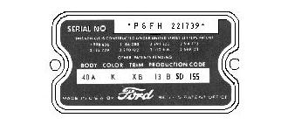
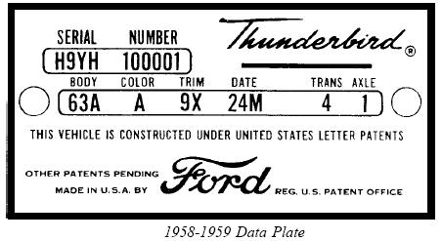
On ’58-’60 Squarebirds it is located on the drivers side door post where the door shuts against the post. Look to see if it has been replaced by a new or other Data Plate. The OEM rivets mounting it to the frame should look like this.

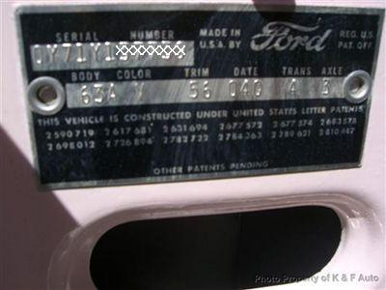

The Data Plate above is for a 1960 Tbird. It differs in style from the 1958-1959 Data Plate. Be wary of the car if the Data Plate is missing, looks like it has been replaced or any of the data on it is missing or appears to have been altered. You should attempt to ascertain why it is missing, or has been altered if possible.

The following are examples of a OEM installed ’58-’59 Data Plate and a replaced ’60 Data Plate. Check out the rivets on it.
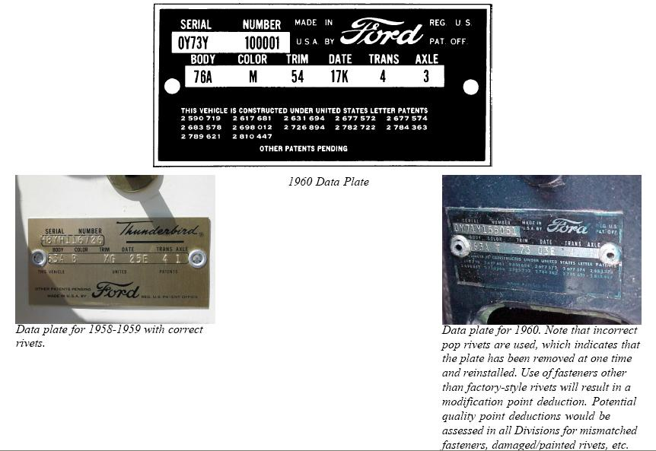

The Data Plate for the 1961-1962 Bulletbird can be found in the same place as the Squarebird. It is located on the driver side door pillar between the door hinges. It is the same Data Plate used for the 1960 Squarebird. According to Alan Tast, the plates moved to the latch face of the driver’s door in ’63 after the first day of production, and continued to be in this location through 1969. The 1964-1966 Data Plate is the same as 1960-1963 and the location is the same for 1963-1966 Tbird.

In addition to the Data Plate ask the seller if they are in possession of the Rotatation Sheet, often called the ROT or Build Sheet. This is the paperwork that the line personnel used to build the car and is a very important historical piece of every car built. It was printed on flimsy paper and has been found in the seat springs, under the carpet, in the center console, in the glove box, under the dash and other places.

EXTERIOR

Paint Condition: Flawless [ ] Very Good [ ] Good [ ] Fair [ ] Poor [ ]
Poor Preparation [ ] Dull [ ] Chipped [ ] Eggshell [ ] Scratches [ ] Flaking [ ] Buffing Required [ ] Some Re-Spray Required [ ]
Full Re-Spray Required [ ]

Body Panel Alignment (Gaps)

Consistent & Regular [ ] Inconsistent or Irregular [ ]
Where? ________________________________________________

Upper Body Corrosion: None Seen [ ] Yes [ ] See Areas With √

F/DS Fender [ ] F/DS/Door [ ] DS/Rocker (Sill) [ ] Hood [ ]
F/PS Fender [ ] F/PS/Door [ ] PS/Rocker (Sill) [ ] Engine Bay [ ]
R/DS Quarter [ ] R/DS/Door [ ] F/Valence [ ] Trunk [ ]
R/PS Quarter [ ] R/DS/Door [ ] R/Valence [ ] Roof [ ]

Upper Body Dents/Dings: None Seen [ ] Yes [ ] See Areas With √

F/DS Fender [ ] F/DS/Door [ ] DS/Rocker (Sill) [ ] Hood [ ]
F/PS Fender [ ] F/PS/Door [ ] PS/Rocker (Sill) [ ] Engine Bay [ ]
R/DS Quarter [ ] R/DS/Door [ ] F/Valence [ ] Trunk [ ]
R/PS Quarter [ ] R/PS/Door [ ] R/Valence [ ] Roof [ ]

LEGEND: F=Front R=Rear DS=Driver Side PS=Passenger Side Valence= Body panels directly above or below front & rear bumpers

Can you see any obvious collision damage? [ ]
If so, describe it: _________________________________________

Re-Spray

Check under the dash, in the trunk, around the doorjambs, bottoms of doors and on the weather stripping and under the hood. Do you see any “over-spray,” unpainted surfaces or signs that the care has been repainted? [ ]

Body Filler: (Bondo)

Do you see any body finish ripples? [ ]
Did you detect any Bondo in body panels? [ ]
If so, state where: ________________________________________
Ask the owner if the car, while in their possession, or, to their knowledge, has ever been in an accident? [ ] Or has been totaled or written off? [ ] If Yes, state where: _________________________

Soft Top (If the car is a convertible)

Condition of the soft top? Very Good [ ] Good [ ] Fair [ ] Poor [ ]
Original top? [ ]
Replacement? Is it?: Factory Original [ ] After Market [ ] Unknown [ ]
Does it operate smoothly? [ ]
Are there any rips or tears? [ ]
Is the stitching coming apart anywhere? [ ]
Does it fit well in the up position? [ ]
Is the top taut in the up position? [ ]
Is the rear window: Clear? [ ] Scratched? [ ] Milky or Yellow? [ ]
Top frame condition: Good [ ] Broken [ ] Needs Paint [ ] Rusted [ ]
Glass & Rubber Gaskets, Moldings

Rubber door & windshield gaskets condition? Good [ ] Fair [ ] Poor [ ]
Any parts: Torn [ ] Split [ ] Missing [ ] If so, where? ______________
Overall glass condition: Good [ ] Fair [ ] Poor [ ]
Broken?[ ] Cracked? [ ] Scratched? [ ] Chipped? [ ] Delaminated? [ ]
If so, state where: _________________________________________
Do window moldings have rust underneath them? [ ]

Exterior Chrome or Stainless (Not Applicable? [ ] )
On a scale of 1-5 , rate the condition of the chrome: 1=Perfect [ ] 2=Very Good [ ] 3=Good [ ] 4=Poor [ ] 5=Scrap [ ]

Some re-plating required? [ ] Some replacing required? [ ] Some polishing required? [ ]
Any dents? [ ] Any pitting/rust? [ ] Any cloudiness or tarnish? [ ]
Is it all there? If not, what is missing? ________________________

LOCKS

Does the owner have the keys? [ ] If so, how many sets? [ ]
Is there a trunk key? [ ]
Does one key operate both front door locks? [ ]
Do the keys fit and work the locks as they should? [ ]

SUSPENSION

Check for sagging springs by looking at the car profile from a distance. It should sit level, front to rear & side to side.
Does the car sit level? [ ]
If no, is it lower At The Back? [ ] At The Front? [ ] Left? [ ] Right [ ]
Press your weight on each corner of the car in turn, bouncing the car six times and let go
Does the car return to it’s regular ride height without continuing to bounce up and down? [ ]

TIRES

What make and size tires are on the car? ______________________
All four tires the same size and make? [ ]
How worn? Like New [ ] Partly Worn [ ] Barely Legal [ ] Cracked [ ]
Cut or Damaged [ ]
If unevenly worn, is the wear on the: Front [ ] Rear [ ] Outside Edge [ ] Inside Edge [ ] Center Or Sides [ ]
Look carefully at the wheel wells, especially in front and back of the tire and the outer lip.
Do you see any signs of: Rust? [ ] Bondo? [ ] Repairs/Patches [ ]
Excessive Undercoating? [ ]

TRUNK

Is there a jack? [ ] Is it correct for the car? [ ]
Is the lug wrench present? [ ]
Is there a jack plate and locking piece? [ ]
Is the spare tire present? [ ]
Does the spare tire/rim match the other car wheels? [ ]
Carpet and side panel condition: Good [ ] Fair [ ] Poor [ ] None [ ]
Any repair or rust through of trunk floor extensions? [ ]

UNDERNEATH

What did you use to inspect the underside of the car?
Lift [ ] Ramps [ ] Floor Jack [ ] Nothing [ ]
Use a mirror to help you check
Do you see any signs of rust, a bent frame or welded in patches? [ ]
If so, where? ____________________________________________
Any leaks at freeze plugs, signs of oil or gas leaks? [ ]
Check the underneath whenever possible. Stab around with an awl or screwdriver, especially the frame, dog legs, jack points, and structural sections (where body, springs, axles, attach to the frame) If anything looks rusted, patched or suspicious, write it down.

Start at the front. Look under the car right where the radiator mounts. The sway bar will be close to the same location. See here.

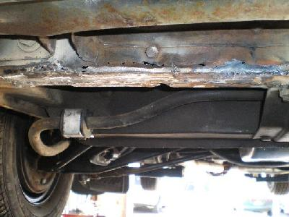

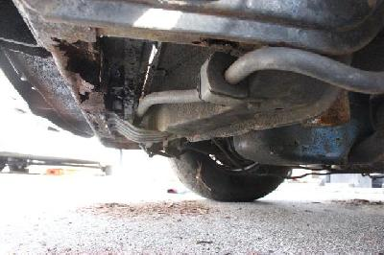

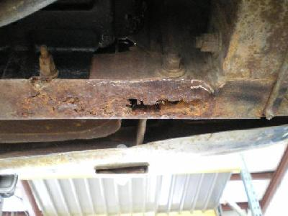

Check under the battery box on the right side.

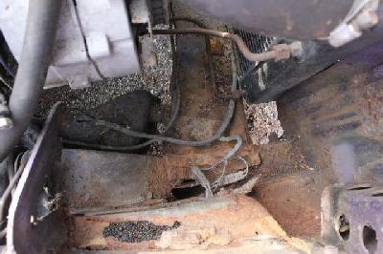

While you have the hood up look at the front edge of the hood. Look closely at the inner fenders where they are spot welded to the doubler plates behind the A arms.

Look inside the wheel opening there should be gravel shields in front of the wheels and behind the wheels. It is not uncommon that they are missing. If the front one are gone you should see the back of the headlights. Feel above them from the backside. Dirt and debri gathers above here and can rust the eyebrows out. Check for previous repairs.

Behind the wheels is the other gravel shield. Behind it is another good hiding spot. This area is prone to rust and runs right down the inner and outer rocker.

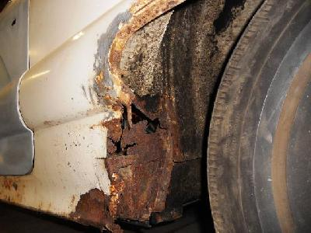

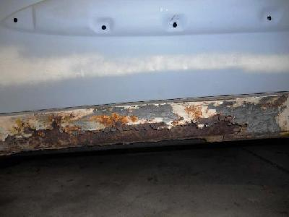
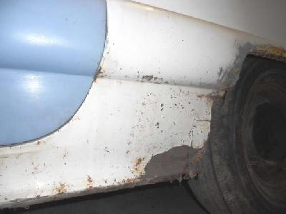

Work your way down both rocker panels. If there is still carpet in the car crawl under it and look for rust holes or repairs. If you find repairs look around them and see if the damage has spread or if there are weak spots around the repairs. If the carpet is out you could see this.

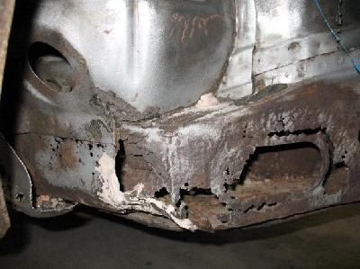

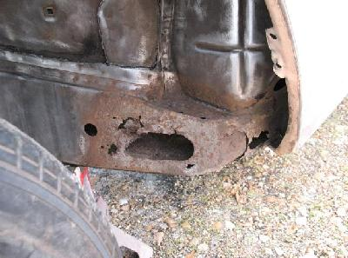

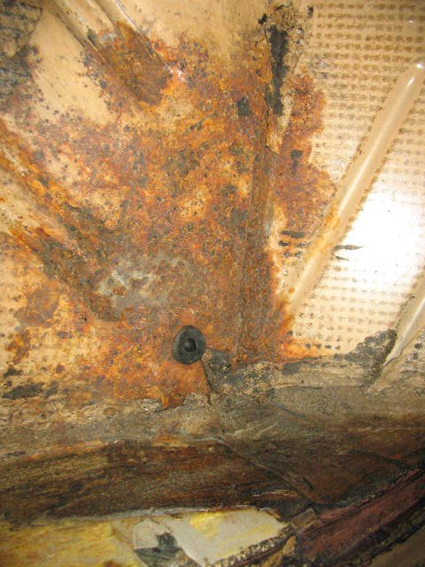

When you get to the rear wheel openings look inside at the front of the opening. All of the mud gravel,etc. Goes up there and sets, draws moisture and rust. Feel the inside of the opening for holes or repairs. Do the same behind the wheel opening. There is a pretty good size brace behind the rear wheels look that over good.

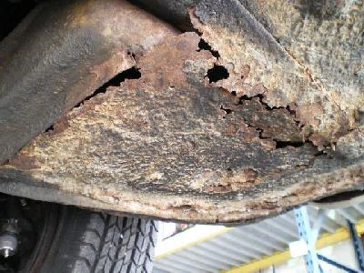

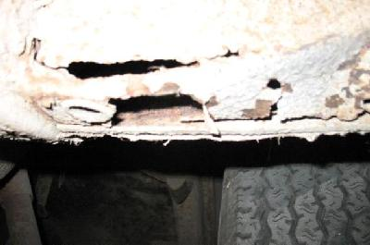

Look at the inner panels that attach the rear 1/4's from the trunk floor. Look between the bumper ends where the ¼ goes behind the bumper. This is spot welded from the factory and sometimes moisture gets in between the spot welds an will make it puffy looking.

If you can look inside the trunk check the spare tire well.

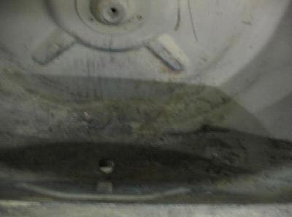

Look around for those puffy spots. There are some factory holes and around these holes rust likes to hang out.

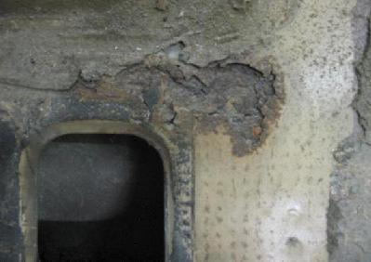

When you are in the trunk look where the tail lights bolt into.

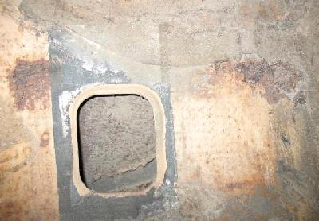

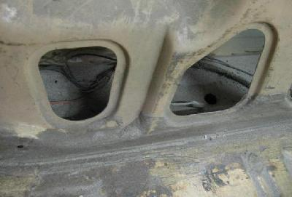

I can only tell you to take your time and be a detective.

Look closely at every panel there might be some signs of previous repairs coming back through.

Note: if no lift was available at the time of the inspection any comments made are based on observations from a prone position. As it is impossible to inspect the underside of a vehicle thoroughly without a lift, DO NOT ASSUME THAT THERE ARE NO ISSUES in this area.

WHEELS

What wheels are on the car? Steel [ ] Alloys [ ] Wires [ ]
Are they original? [ ]
Overall condition? Very Good [ ] Good [ ] Fair [ ] Poor [ ]
If chrome, what condition? Very Good [ ] Good [ ] Fair [ ] Poor [ ]
If painted, what condition? Very Good [ ] Good [ ] Fair [ ] Poor [ ]
If wires, any missing or damaged spokes? [ ]
Are the knockoffs damaged? [ ]
If Hubcaps/Wheel Trims are fitted, what condition are they in?
Very Good [ ] Good [ ] Fair [ ] Poor [ ]

ELECTRICS

Do the indicators work? [ ] Do the hazard warning lights work? [ ]
Do the parking lights work? [ ] Not Applicable [ ]
Do the head lights work? High Beam [ ] Low Beam [ ]
Do the instrument lights work? [ ] Horn work? [ ] Interior lights? [ ]
Do the brake lights work? [ ] Do the rear lights work? [ ]
Do the reversing lights work? [ ] License Plate lights work? [ ]
Does the car have electric windows? [ ] If yes, do they work? [ ]
Does the car have an electric convert. top or sunroof? Does it work? [ ]
Do the windshield wipers work? [ ] If the car has windshield washers installed do they work? [ ] Not Applicable [ ]
Do all the gauges appear to be original? [ ] Do they all work? [ ]
Do any gauges or switches appear to be missing? [ ] If any are, which? __________________________________________________
Does the car have Air Conditioning? [ ] If Yes, does it blow cold? [ ]
Does the car have a heater? [ ] If Yes, does it blow hot? [ ]

ENGINE BAY (With engine off):

Does it have a: 352CI [ ] 430MEL [ ] 390CI [ ] 428 [ ] Engine?
A 352CI engine has the radiator over flow tank parallel to the radiator
A 430MEL engine has the radiator over flow tank on the passenger side of the engine with the end of it pointing towards the firewall
Any missing or add on parts/components? [ ]
Is the carb a 4 bbl Ford carb? (352) [ ] or a 4 bbl Carter? (430) [ ]
Does the Hood/Bonnet open easily? [ ]
Hood/Bonnet underside? [ ] Clean? [ ] Somewhat Dirty? [ ] Very Dirty? [ ]
Engine bay Clean? [ ] Somewhat Dirty? [ ] Very Dirty? [ ]
Any loose, cracked, brittle or frayed wires or electrical cables? [ ]
Engine bay paint match the car? [ ] If not, what color is it? ________
Any coolant on the floor under the car? [ ] If Yes, is there a lot? [ ]
Any oil visible on engine? [ ] If Yes, is there a lot? [ ]
Any oil visible on the floor under the car? [ ] If Yes, is there a lot? [ ]
Any transmission fluid on the floor under the car? [ ] If Yes, a lot? [ ]
Is the amount of oil in the engine at the manufacturers recommended level? [ ] (Check dipstick) [ ]
Does the oil look Black? [ ] Milky coffee colored or droplets of moisture, indicating water in the oil? [ ] Recent oil change? [ ]
Rust on frame, core support, front floor toe boards? [ ]
Does either the engine oil or transmission fluid smell burnt?
Engine [ ] Transmission [ ]
If the transmission is an automatic, check the dipstick. Does the fluid look Pink? [ ] Brown? [ ]

ENGINE (With engine running – from inside the car):

Did the car start easily? [ ]
Were there any “clanks” when the car first started up? [ ]
Does the car have an oil pressure gauge? [ ]
If Yes, what does the oil pressure gauge read? Circle one of the following: L | N | H or _______ lbs
(From beneath the Hood/Bonnet)
Does the car idle Smoothly? [ ] Somewhat Rough? [ ] Very Rough [ ]
While the engine is still cold Remove the radiator cap. Is there coolant visible? [ ] If Yes, do you see any air bubbles surfacing in the water? [ ] Do you see any oil in the water? [ ]
Rev the engine a few times – do you see any smoke coming out of the tail pipes? [ ] If Yes, what color is it? Black? [ ] White? [ ] Light Gray? [ ] Light or Dark Blue? [ ]
Remove the valve cover cap and check for “blow-by”. Does any smoke blow out of it? [ ]

Slowly bring the car up to operating temperature. Once you’ve reached this point, gradually depress the accelerator, as the car comes up through the rev. range listen carefully to the engine, and note any “Growls”, “rattles”, or “knocks”.

GEARBOX – AUTOMATIC
From a standstill with the engine running, apply the parking brake firmly, put the car in “Reverse” and then in “Drive” – Do you notice any “clunks” from the drive train? [ ]
Now depress the accelerator gently while in drive.
Does the car “hunker down”, labor or nearly stall? [ ] Or move? [ ]
With the parking gear release, begin the road test, but “manually” shift through the gears and note the smoothness or the “change”.
Do the gears engage and disengage smoothly? [ ]
Notice any “clunks” from the drive train? [ ]
If Yes, Describe ___________________________________________

GEARBOX – MANUAL
With the car at a standstill, but with the engine running, apply the hand brake, depress the clutch and engage second gear; now try to drive off.
Does the brake hold the car from moving? [ ] Any clutch slippage? [ ]
Now depress the clutch and select each gear in turn.
Does the clutch operate smoothly? [ ] Gears engage smoothly? [ ]
Do any of the gears / syncros seem noisy? [ ]

INTERIOR

Seat coverings?: Vinyl [ ] Leather [ ] Cloth [ ] Other material [ ]
Are they original seat covers? [ ]
Condition? Very Good [ ] Good [ ] Fair [ ] Poor [ ] Dirty [ ]
Original material been?: Replaced [ ] Repaired [ ] Restored [ ]
Any rips, tears, or broken stitching? [ ]
Do the seats operate easily, front/back, recline, etc.? [ ]
Is there any interior wood trim? [ ] Is it all there? [ ]
Condition? Perfect [ ] Very Good [ ] Good [ ] Fair [ ] Poor [ ]
Is there any interior chrome? [ ] Is it all there? [ ]
Condition? Perfect [ ] Very Good [ ] Good [ ] Fair [ ] Poor [ ]
Any Flaking or rust? [ ] Pitting? [ ]
Any oxidation or tarnishing? [ ]
Any plating or replacing required? [ ] Any fittings missing? [ ]
If Yes, What? ____________________________________________
Condition of headliner? Very Good [ ] Good [ ] Fair [ ] Poor [ ]
Any rips or tears? [ ] Is it dirty or stained? [ ]
Is there a sunroof? [ ] Does it open/close properly? [ ] Leaks? [ ]
Condition of carpets? Very Good [ ] Good [ ] Fair [ ] Poor [ ]
Do they need cleaning? [ ] Replacing? [ ] Are they wet? [ ]
Lift the carpets if you can. See any rust in the floor pans? [ ]
Does the car have a radio? [ ] Does it work? [ ] Speakers work? [ ]
Does it have a tape player? [ ] CD player/changer? [ ]
Do the doors operate easily from within the car? [ ]
Inside door panel condition? Very Good [ ] Good [ ] Fair [ ] Poor [ ]
Are they? Loose [ ] Damaged [ ] Warped [ ]
Do all windows operate easily? [ ]
Do door locks work and operate smoothly? [ ]
Does any door rattle when closing it? [ ] If Yes, which? ___________
Do the doors drop when opened? [ ] Do they align correctly? [ ]

TRANSMISSION

Bell housing: Cast Iron [ ] Until late 1960, then: Aluminum [ ]
Any leaks, damage? [ ]
Linkage in place. Tight movement at shift column? [ ]
Engine running, shift through gears, firm engagement, no noises? [ ]

TEST DRIVE (Required)

Once on the road, check the foot brakes.
Do the brakes pull to one side? [ ]
Do the gears still engage and disengage smoothly? [ ]
Check oil pressure now? (Circle one) L | N | or _____ lbs. No Gauge [ ]
Does the car have Overdrive or Turbo? [ ] If so, does it seem to engage and disengage correctly? [ ]
Did you notice any misfire? [ ]
Does the car run Smoothly? [ ] Somewhat rough? [ ] Very Rough [ ]
With you hands momentarily off the steering wheel, does the car continue to go in a straight line? [ ]
In a parking lot or similar safe open area, at a slow speed turn a tight “figure eight”
Did you hear any unusual noises? [ ]
Where there any other “odd” noises you heard while driving? [ ]
If Yes, describe: ___________________________________________

Where you able to test drive the car? [ ]
If Not, Why? _____________________________________________
Did you drive it on the road? [ ] In a Parking lot/Driveway? [ ]
Approximately how far? __________ Miles
Who drove it? I Did [ ] The Seller Did [ ]

PAPERWORK

Check the title for authenticity and proof of ownership.
Is the title Regular? [ ] Salvage? [ ] Other/Special? [ ]
Not Available? [ ]
If Not Available, did you see a: Bill Of Sale? [ ] Certificate Of Registration? [ ]
Does the VIN # on the vehicle match the title or registration certificate? [ ]
Are there any receipts, service records, shop/operating manuals? [ ]
Is the ROT/Build Sheet available? [ ]

Comments: _______________________________________

NOTES: __________________________________________

